**IMSOP - System Architecture**

**Overview**

IMSOP (Intelligent Multi-Cloud Supply Chain & Operations Platform) is an enterprise-grade supply chain management and operations platform. It provides comprehensive visibility, control, and optimization across Azure-centric environments with optional multi-cloud support via Azure Arc, ensuring robustness, security, and high performance through containerization, IaC, and advanced monitoring.

**System Architecture Diagram**

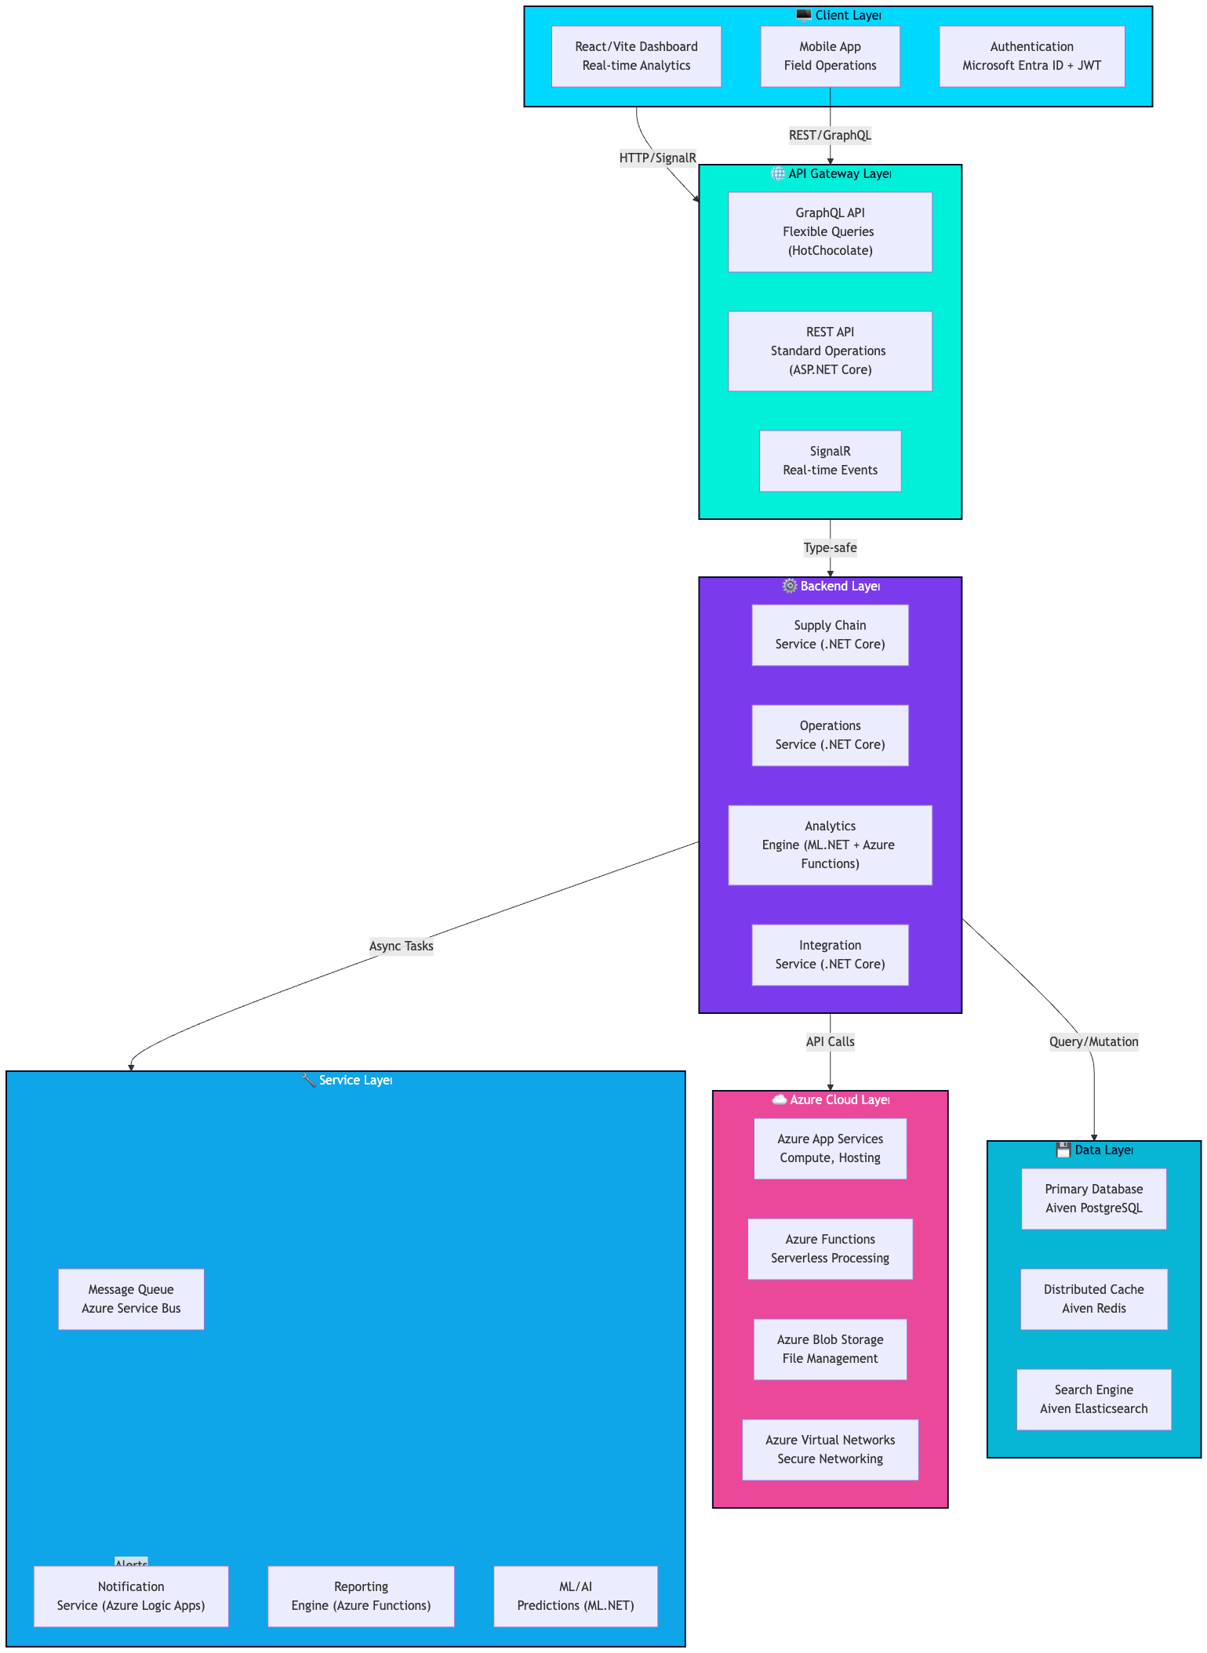

**Component Details**

**Client Layer**

* **React/Vite Dashboard**: Comprehensive supply chain analytics and management, deployed on Vercel for fast static hosting with SSR support.
* **Mobile App**: Field operations and real-time updates (React Native integration).
* **Authentication**: Microsoft Entra ID (Azure AD) with JWT tokens and OAuth 2.0.

**API Gateway Layer**

* **GraphQL API**: Flexible query language using HotChocolate for complex data requirements.
* **REST API**: Standard CRUD operations with ASP.NET Core Web API, secured via Azure API Management.
* **SignalR**: Real-time event streaming and notifications for high-performance updates.

**Backend Layer**

* **Supply Chain Service**: Procurement, inventory, logistics management (DDD with SOLID principles).
* **Operations Service**: Workflow automation, task management (Async processing).
* **Analytics Engine**: Predictive analytics using ML.NET and Azure Functions.
* **Integration Service**: Third-party API integrations via Azure Logic Apps and Microsoft Graph API.

**Data Layer**

* **Aiven PostgreSQL Database**: Managed primary data storage with ACID compliance and auto-scaling.
* **Aiven Redis Cache**: High-performance caching layer for distributed sessions and data.
* **Aiven Elasticsearch**: Full-text search and log aggregation, integrated with Azure Monitor.

**Azure Cloud Layer**

* **Azure App Services**: Hosting for .NET Core microservices.
* **Azure Functions**: Serverless compute for event-driven tasks.
* **Azure Blob Storage**: Secure file storage with encryption.
* **Azure Virtual Networks**: Isolated networking with RBAC and Managed Identities.

**Service Layer**

* **Message Queue**: Azure Service Bus for asynchronous task processing.
* **Notification Service**: Azure Logic Apps for email/SMS/push notifications.
* **Reporting Engine**: Azure Functions for PDF generation and scheduled reports.
* **ML/AI**: ML.NET models deployed in Azure Functions for predictions.

**Data Flow**

**Supply Chain Order Flow**

**1. Intake & Validation**

The process begins when a user submits an order. Before any data hits the database, it must pass a logic gate.

* **Order Creation:** The initial POST request.
* **Validation (FluentValidation):** Ensures the data is structurally sound (e.g., valid email formats, non-empty fields, positive quantities).
* **Inventory Check (EF Core):** A synchronous check against the database to ensure the items are currently in stock.

**2. Decoupling & Queuing**

Once validated, the system avoids "blocking" the user by offloading the heavy lifting.

* **Queue Processing (Azure Service Bus):** The order is published as a message to a topic or queue. This ensures that even if the supplier service is down, the order is safely persisted and ready for processing.

**3. Execution & Fulfillment**

The backend workers pick up the message from the Service Bus to complete the transaction.

* **Supplier Notification:** An automated trigger (likely a Function or Microservice) notifies the warehouse or third-party supplier.
* **Fulfillment:** The physical process of picking, packing, and readying the item for shipping.

**4. Real-time Updates & Monitoring**

As the order moves toward the customer, the system provides transparency and logs performance.

* **Shipment Tracking (SignalR):** Instead of the user refreshing their page, SignalR pushes "Live" status updates (e.g., "Picked," "Shipped") directly to the client UI in real-time.
* **Delivery & Analytics Update (Azure Monitor):** Once the cycle is complete, the telemetry data is sent to Azure Monitor/Application Insights to track success rates, latency, and potential bottlenecks.

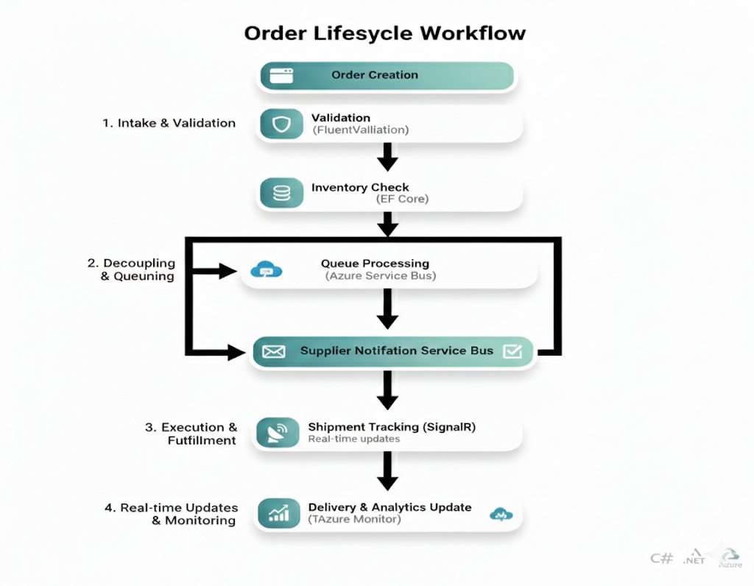

**Data Pipeline Architecture**

**1. Ingestion & Pre-processing**

The journey begins with the raw data entry point.

* **Data Sources:** External APIs, IoT sensors, or database logs.
* **Collection (.NET Worker):** A lightweight, long-running background service responsible for polling or listening to data sources and pushing them into the cloud environment.

**2. Transformation & Storage**

Once the data is inside the cloud, it needs to be "cleaned" and stored for fast access.

* **Processing (Azure Functions):** Serverless compute handles the business logic, data normalization, and transformation. This scales automatically based on the volume of incoming data.
* **Cache Update (Aiven Redis):** Instead of hitting a slow primary database, processed data is pushed to a high-speed **Redis** instance. This ensures the "latest state" of the data is available with sub-millisecond latency.

**3. Real-time Delivery & Monitoring**

The final layer focuses on getting that data in front of the right eyes immediately.

* **Dashboard Update (SignalR):** Rather than having users refresh a browser, SignalR pushes the updated Redis values directly to the front-end dashboard via WebSockets.
* **Alert Generation (Azure Monitor):** If the data processing identifies an anomaly or exceeds a predefined threshold, Azure Monitor triggers automated alerts (Email, SMS, or Webhooks).

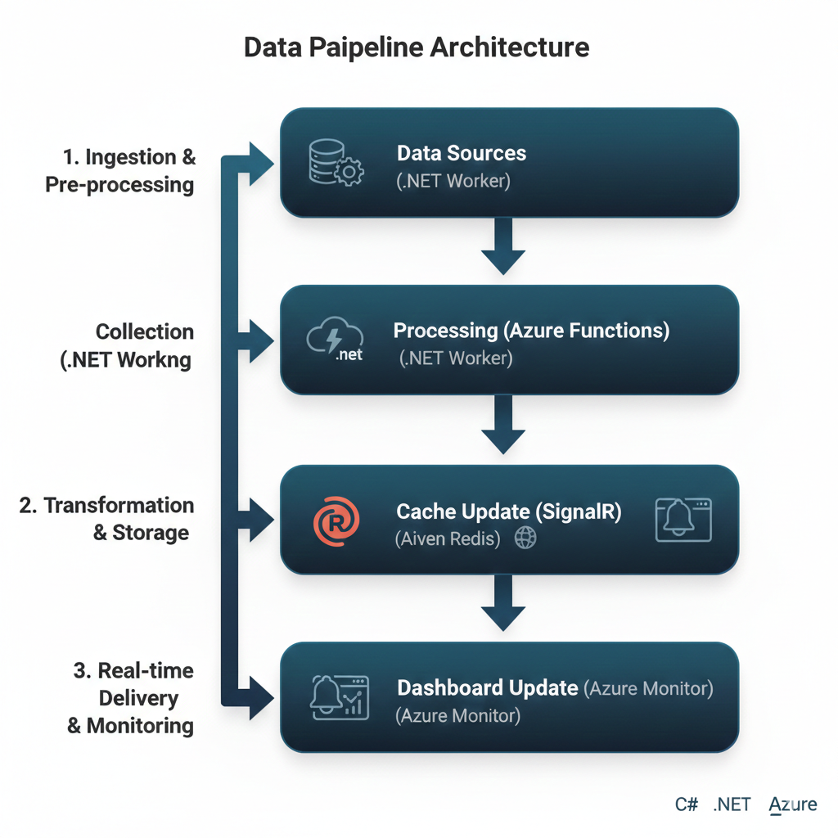

**Hybrid Request & Integration Workflow**

**1. The Gateway Layer**

* **Local Request:** This is the entry point, likely originating from an on-premises application or a local user terminal.
* **Cloud Router (.NET Core):** A high-performance middleware built on .NET Core that acts as the intelligent traffic cop. It determines how to handle the request based on geography, load, or security rules.

**2. The Hybrid Bridge**

* **Azure Selection (via Azure Arc):** This is the "brain" of the hybrid setup. **Azure Arc** allows you to manage non-Azure resources as if they were native. The router uses Arc to select the most appropriate Azure region or localized resource to handle the heavy lifting.
* **Azure API Call (SDK):** Once the target is identified, the system uses the official Azure SDK to securely trigger cloud services (like Storage, AI, or Compute).

**3. Aggregation & Delivery**

* **Result Aggregation (Azure Functions):** Since an API call might return raw or fragmented data, a serverless **Azure Function** sits in the middle. It "massages" the data, combines it with other necessary context, and prepares the final payload.
* **Response to Client:** The cleaned, aggregated data is sent back through the router to the local user, completing the cycle with minimal latency.

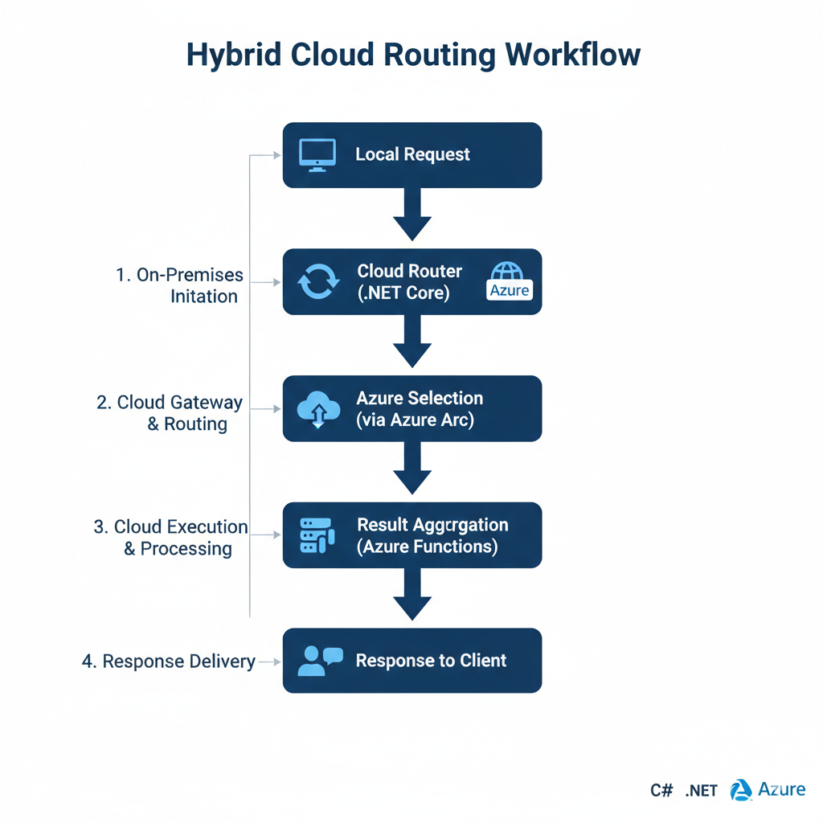

**Technology Stack**

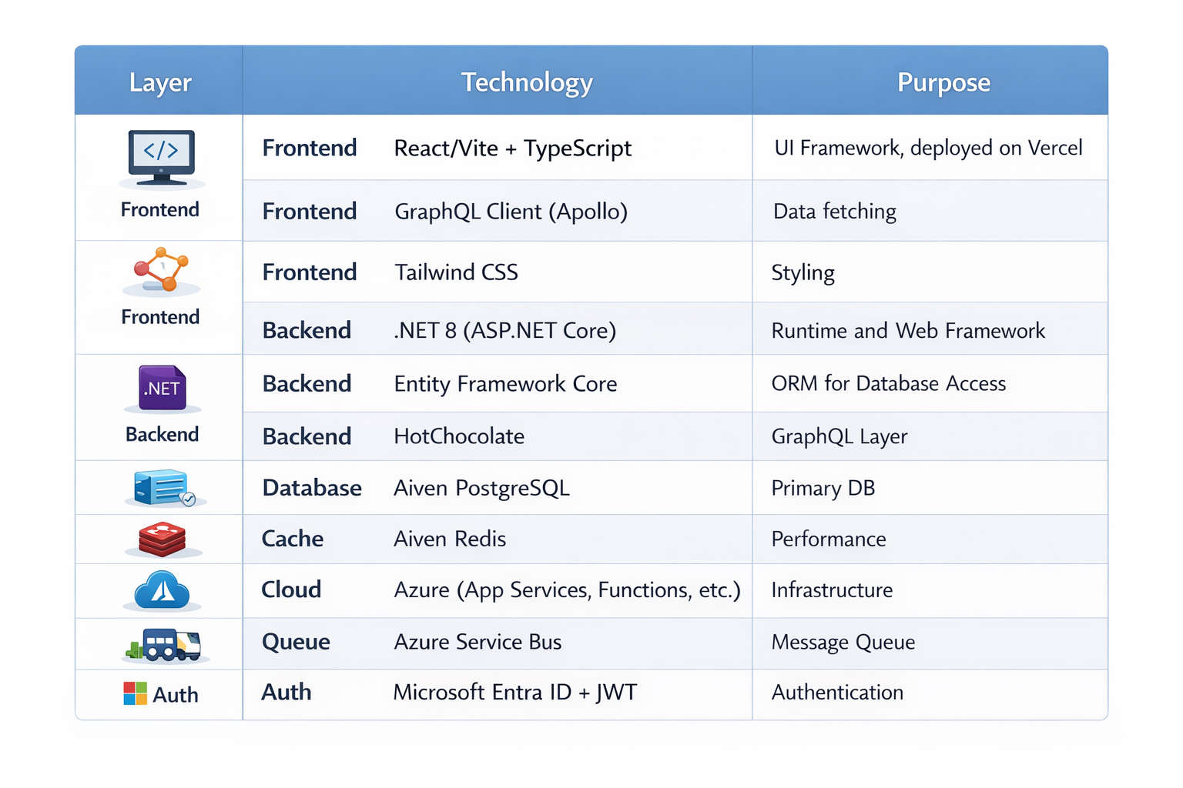

**Key Features**

**1. Supply Chain Management**

* Procurement automation
* Inventory optimization
* Supplier management
* Purchase order tracking

**2. Operations Management**

* Workflow automation
* Task management
* Resource allocation
* Performance tracking

**3. Analytics & Insights**

* Real-time dashboards
* Predictive analytics
* Anomaly detection
* Custom reports

**4. Azure-Centric Support**

* Azure App Services integration
* Azure Functions for serverless
* Azure Arc for hybrid/multi-cloud
* Secure networking with Virtual Networks

**5. Integration Capabilities**

* ERP system integration via Azure Logic Apps
* Third-party API support (OAuth 2.0)
* Data synchronization with Microsoft Graph API
* Webhook support

**Security Architecture**

**Authentication**

* Microsoft Entra ID for third-party integrations
* JWT for API authentication
* Multi-factor authentication support
* Session management with Managed Identities

**Authorization**

* Role-based access control (RBAC) via Azure
* Attribute-based access control (ABAC)
* Resource-level permissions
* Audit logging with Azure Monitor

**Data Protection**

* End-to-end encryption (Azure Key Vault)
* Database encryption at rest (Aiven)
* TLS/SSL in transit
* Data anonymization and secrets management

**Scalability Considerations**

**Horizontal Scaling**

* Stateless microservices in Docker/Kubernetes
* Load balancing via Azure App Service
* Database replication (Aiven auto-scaling)
* Cache distribution (Aiven Redis Cluster)

**Performance Optimization**

* Query optimization with EF Core
* Caching strategies (IDistributedCache)
* Batch processing in Azure Functions
* Asynchronous operations with async/await in .NET

**Monitoring & Observability**

* Azure Monitor and Application Insights for logging
* Log Analytics for centralized logs
* Alerting and performance optimization
* Root cause analysis with troubleshooting tools

**Deployment Architecture**

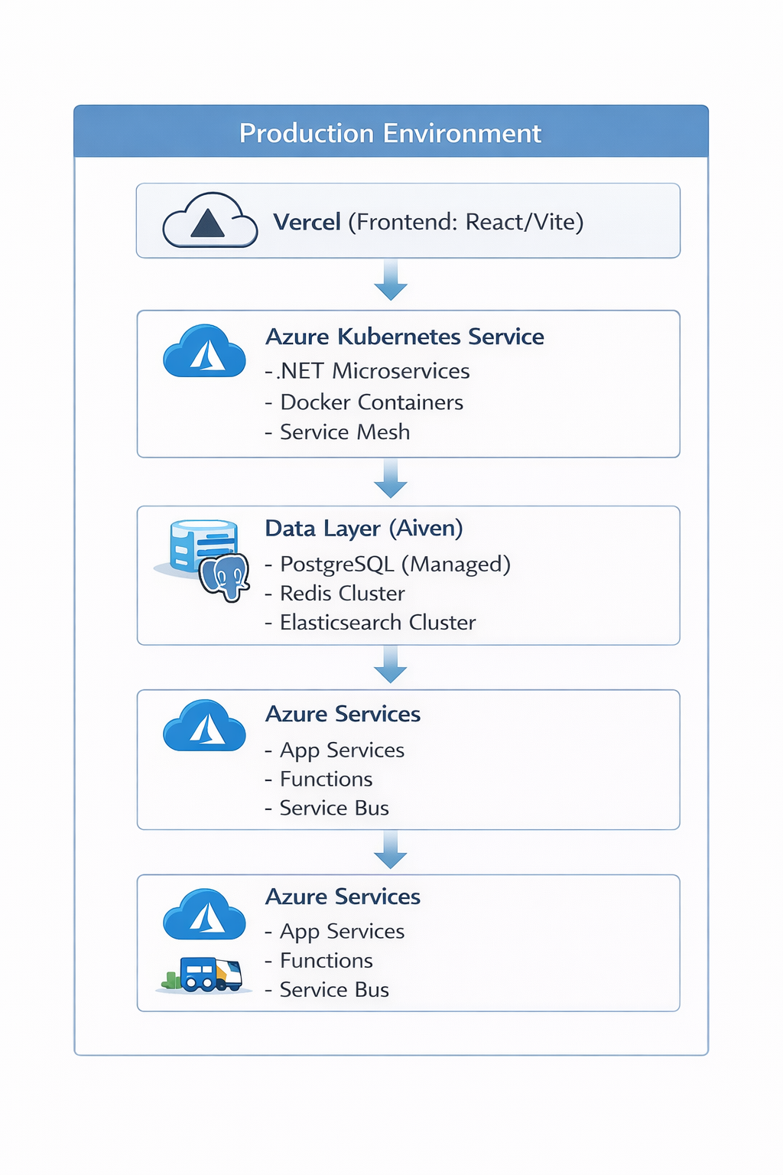

**Deployment Tools:**

* IaC: Azure Bicep/ARM Templates for infrastructure provisioning.
* CI/CD: Azure DevOps Pipelines or GitHub Actions for automated builds, tests (TDD), and deployments.
* Static Assets: GitHub Pages for documentation/hosting static parts if needed, Render for backend preview environments.

**SOLID Principles Implementation**

**Single Responsibility**

* Each service handles one domain
* Clear separation of concerns
* Focused business logic

**Open/Closed**

* Extensible through plugins
* New integrations without modification
* Interface-based design

**Liskov Substitution**

* Consistent service interfaces
* Predictable behavior
* Type-safe operations

**Interface Segregation**

* Minimal required dependencies
* Focused service contracts
* Specific API endpoints

**Dependency Inversion**

* Services depend on abstractions
* Dependency injection pattern
* Plugin architecture

**Performance Metrics**

* **API Response Time**: < 200ms (p95)
* **GraphQL Query Time**: < 500ms (p95)
* **Real-time Event Latency**: < 100ms
* **Dashboard Load Time**: < 2s
* **Database Query Time**: < 50ms (p95)
* **Cache Hit Rate**: > 85%
* **System Availability**: > 99.9%

**Future Enhancements**

1. **Advanced Analytics**
   * Machine learning models
   * Predictive maintenance
   * Demand forecasting
2. **Blockchain Integration**
   * Supply chain transparency
   * Smart contracts
   * Immutable audit trail
3. **IoT Integration**
   * Real-time tracking
   * Sensor data collection
   * Automated alerts
4. **Advanced Automation**
   * RPA integration
   * Workflow optimization
   * Intelligent routing
5. **Sustainability**
   * Carbon footprint tracking
   * Green logistics optimization
   * ESG reporting